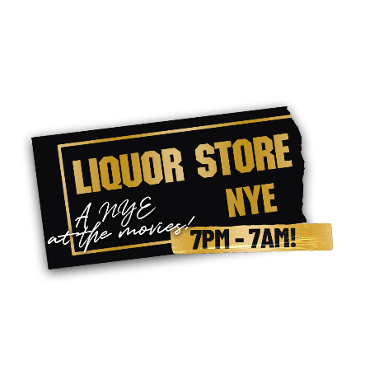
Table Packages

'Bill & Ted's Most Excellent Package' (2 people)
4 x 'Cocktails of the Big Screen'
! x Bottle of Chio Prosecco
1 x Bottle of Pinot Grigio/Chardonnay/Rose/Merlot
2 x Popcorn
2 x Movie masks
Confetti Popper for Midnight
£80

‘The Goonies – Hey You Guys! Package’ (6 people)
6 x 'Cocktails of the Big Screen'
6 x Bottles of Corona
3 x Bottles of Chio Prosecco
1 x Baby Guinness Shot Tree for 6 people
6 x Popcorn
6 x Movie Masks
Confetti Popper for Midnight
£200
*Plus, if booked as a table of 6 more you will receive a Free Bottle of Champagne and Bottomless Nachos for the table

‘The Brewsters Millions High Roller Package’ (12 people)
12 x 'Cocktails of the Big Screen'
2 x Bottles of Veuve Clicquot Champagne
1 x Bottle of Grey Goose vodka with mixers
1 x Bottle of Jack Daniels whiskey with mixers
1 x Bottle of Patron XO Café tequila
15 x Bottles of Corona or Peroni
12 x Popcorn
12 x Movie Masks
2 x Large Confetti Cannons for Midnight
£750
*Plus, if booked as a table of 6 more you will receive a Free Bottle of Champagne and Bottomless Nachos for the table

